Web-Based Health Diagnosis System

A PROJECT REPORT

Submitted by

P.V.Hemachandra [RA2211003011040]
N.Rohan Teja [RA2211003011052]

Under the Guidance of

Dr.K.Anitha

Associate Professor
Department of Computing Technologies

in partial fulfillment of the requirements for the degree

of

BACHELOR OF TECHNOLOGY

in

COMPUTER SCIENCE ENGINEERING


DEPARTMENT OF COMPUTING TECHNOLOGIES

COLLEGE OF ENGINEERING AND TECHNOLOGY

SRM INSTITUTE OF SCIENCE AND TECHNOLOGY

KATTANKULATHUR- 603 203

APRIL 2025


Department of Computing Technologies

SRM Institute of Science & Technology

Own Work* Declaration Form

This sheet must be filled in (each box ticked to show that the condition has been met). It must be signed and dated along with your student registration number and included with all assignments you submit – work will not be marked unless this is done.
To be completed by the student for all assessments

Degree/ Course : B-TECH/ CSE (CORE)

Student Name : P.V.Hemachandra, N.Rohan Teja

Registration Number :RA2211003011040, RA2211003011052

Title of Work : Web-Based Health Diagnosis System
I / We hereby certify that this assessment compiles with the University’s Rules and Regulations relating to Academic misconduct and plagiarism**, as listed in the University Website, Regulations, and the Education Committee guidelines.

I / We confirm that all the work contained in this assessment is my / our own except where indicated, and that I / We have met the following conditions:

- Clearly referenced / listed all sources as appropriate
- Referenced and put in inverted commas all quoted text (from books, web, etc)
- Given the sources of all pictures, data etc. that are not my own
- Not made any use of the report(s) or essay(s) of any other student(s) either past or present
- Acknowledged in appropriate places any help that I have received from others (e.g. fellow students, technicians, statisticians, external sources)
- Compiled with any other plagiarism criteria specified in the Course handbook / University website
I understand that any false claim for this work will be penalized in accordance with the University policies and regulations.

DECLARATION:
I am aware of and understand the University’s policy on Academic misconduct and plagiarism and I certify that this assessment is my / our own work, except where indicated by referring, and that I have followed the good academic practices noted above.
If you are working in a group, please write your registration numbers and sign with the date for every student in your group.



SRM INSTITUTE OF SCIENCE AND TECHNOLOGY KATTANKULATHUR – 603 203

BONAFIDE CERTIFICATE

Certified that 21CSP302L - Minor Project report titled “Web-Based Health Diagnosis System” is the bonafide work of “P.V.Hemachandra [RA2211003011040], N.Rohan Teja [RA2211003011052]” who carried out the project work under my supervision. Certified further, that to the best of my knowledge the work reported herein does not form any other project report or dissertation on the basis of which a degree or award was conferred on an earlier occasion on this or any other candidate.

SIGNATURE SIGNATURE
Dr K.ANITHA Dr G. NIRANJANA
SUPERVISOR  ASSOCIATE PROFESSOR  DEPARTMENT OF COMPUTING TECHNOLOGIES |  | PROFESSOR &HEAD  DEPARTMENT OF  COMPUTING TECHNOLOGIES

ACKNOWLEDGEMENTS
We express our humble gratitude to Dr. C. Muthamizhchelvan, Vice-Chancellor, SRM Institute of Science and Technology, for the facilities extended for the project work and his continued support.
We extend our sincere thanks to Dr. Leenus Jesu Martin M, Dean-CET, SRM Institute of Science and Technology, for his invaluable support.
We wish to thank Dr. Revathi Venkataraman, Professor and Chairperson, School of Computing, SRM Institute of Science and Technology, for her support throughout the project work.
We encompass our sincere thanks to, Dr. M. Pushpalatha, Professor and Associate Chairperson - CS, School of Computing and Dr. Lakshmi, Professor and Associate Chairperson -AI, School of Computing, SRM Institute of Science and Technology, for their invaluable support.
We are incredibly grateful to our Head of the Department, Dr G. Niranjana , Professor and Head, Department of Computing Technologies, SRM Institute of Science and Technology, for her suggestions and encouragement at all the stages of the project work.
We want to convey our thanks to our Project Coordinators, Panel Head, and Panel Members Department of Computing Technologies, SRM Institute of Science and Technology, for their inputs during the project reviews and support. We register our immeasurable thanks to our Faculty Advisor, Dr M.Kandan, Department of Computing Technologies, SRM Institute of Science and Technology, for leading and helping us to complete our course.
Our inexpressible respect and thanks to our guide, Dr K.Anitha, Department of Computing Technologies, SRM Institute of Science and Technology, for providing us with an opportunity to pursue our project under her mentorship. She provided us with the freedom and support to explore the research topics of our interest. Her passion for solving problems and making a difference in the world has always been inspiring.
We sincerely thank all the staff members of Computing Technologies, School of Computing, S.R.M Institute of Science and Technology, for their help during our project. Finally, we would like to thank our parents, family members, and friends for their unconditional love, constant support and encouragement
P.V.Hemachandra
N.Rohan Teja

ABSTRACT

In the contemporary era of digital transformation, the healthcare sector is increasingly embracing intelligent technologies to augment diagnostic accuracy and operational efficiency. One critical challenge in early-stage disease detection is the lack of adaptive and reliable diagnostic tools that can dynamically interpret both structured and unstructured patient data. Traditional symptom checkers often operate on rigid logic or manually coded rules, which limits their adaptability, personalization, and precision. Recognizing these limitations, our project introduces an advanced Intelligent Disease Prediction System (IDPS) aimed at improving preliminary diagnostics using a hybrid of semantic reasoning and machine learning algorithms. This intelligent system is specifically designed to analyze patient health data, draw meaningful inferences, and assist healthcare administrators in making better-informed decisions. The backend leverages a semantic knowledge base the Human Disease Diagnosis Ontology (HDDO) to reason through symptom-disease relationships and uncover latent associations that are often missed in rule-based systems. HDDO enables a structured, hierarchical representation of medical knowledge, enhancing the contextual understanding of symptoms and disease manifestations. To address the challenges associated with unstructured health data, particularly free-text patient inputs or image-based inputs, the system integrates a Convolutional Neural Network (CNN). The CNN component is trained to extract deep patterns and features that contribute to more nuanced and accurate predictions. This dual approach combining semantic reasoning and deep learning allows the system to tackle a wide variety of diagnostic scenarios with increased accuracy and confidence. The system is currently implemented with admin-only access using a web-based interface developed in Java (NetBeans IDE), with MySQL databases managed via SQLyog. The admin has the authority to manage patient records, monitor model outputs, perform data preprocessing, and generate diagnostic reports. Symptom Mapping which Automatically maps patient symptoms to probable diseases using the HDDO framework.

TABLE OF CONTENTS

ABSTRACT v
TABLE OF CONTENTS vi,vii
LIST OF FIGURES viii, ix
LIST OF TABLES x
ABBREVIATIONS xi

CHAPTER NO. TITLE PAGE NO.

1 INTRODUCTION 12

1.1 Introduction to Project 12
1.2 Motivation 13
1.3 Sustainable Development Goal of the Project 13
1.4 Product Vision Statement 14
1.5 Product Goal 15
1.6 Literature Survey 15
1.7 Product Backlog (Key User Stories with Desired Outcomes) 16
1.8 Product Release Plan 17

2 SPRINT PLANNING AND EXECUTION 18

2.1 Sprint 1 18 2.1.1 Sprint Goal with User Stories of Sprint 1 18-20
2.1.2 Functional Document 21-23
2.1.3 Architecture Document 24-29
2.1.4 UI Design 30
2.1.5 Functional Test Cases 31
2.1.6 Daily Call Progress 31
2.1.7 Committed vs Completed User Stories 32
2.1.8 Sprint Retrospective 33

2.2 Sprint 2 33
2.2.1 Sprint Goal with User Stories of Sprint 2 33-35
2.2.2 Functional Document 36,37
2.2.3 Architecture Document 38,39
2.2.4 UI Design 40
2.2.5 Functional Test Cases 41
2.2.6 Daily Call Progress 41
2.2.7 Committed vs Completed User Stories 42
2.2.8 Sprint Retrospective 42
2.3 Sprint 3 43
2.3.1 Sprint Goal with User Stories of Sprint 2 43-45
2.3.2 Functional Document 46,47
2.3.3 Architecture Document 47,48
2.3.4 UI Design 49
2.3.5 Functional Test Cases 50
2.3.6 Daily Call Progress 50
2.3.7 Committed vs Completed User Stories 51
2.3.8 Sprint Retrospective 51
3. RESULTS AND DISCUSSIONS 52
3.1 Project Outcomes (Justification of outcomes and how they align with the goals) 52,53
3.2 Committed vs Completed User Stories 53
4 CONCLUSION & FUTURE ENHANCEMENT 54
REFERENCES 55
APPENDIX 56
A. SAMPLE CODING 56-58
B. PLAGIARISM REPORT 59
LIST OF FIGURES
CHAPTER NO TITLE PAGE NO.
1.1 MS Planner Board of Web-Based Health Diagnosis System…………………..17
1.2 Release plan of Web-Based Health Diagnosis System…………...................... 18
2.1 image of User-story for Admin Access………………………...……………... 19
2.2 User Story viewing Patients Records………………………………………… 20
2.3 System Architecture Diagram ………………………………………………... 21
2.4 Entity-Relationship (ER) Diagram ……………………………………………25
2.5 Schema Design ………………………………………………………………..25
2.6 Use-Case Diagram……………………………………………………………..26
2.7 Class Diagram…………………………………………………………………..26
2.8 Communication diagram……………………………………………………….27
2.9 Deployment Diagram…………………………………………………………..27
3.0 Data Flow Diagram ( Level 0 and 1)….………………………………..………28
3.1 UI design for Landing Page………………………………………….…………30
3.2 UI Design for Login Page……………………………………………..………..31
3.3 Standup Meetings………………………………………………………..……..32
3.4 Bar graph for Committed Vs Completed User Stories…………………..……...33
3.5 Sprint Retrospective for the Sprint 1……………………………………..……..34
3.6 User Story for Generating Diagnosis Report……………………………..…….35
3.7 User story for Updating Patient Records…………………………………...…...35
3.8 Architecture Diagram for Sprint 2……………...……………………………….38
3.9 UI design for Viewing, maintaining and Updating the dataset………………….40
4.0 UI design for generating the Report……………………………………….…….40
4.1 Standup Meeting………………………………………………………………...41
4.2 Bar graph for Committed Vs Completed User Stories………………………….42
4.3 Sprint Retrospective for the Sprint 2……………………………………………43
4.4 User Story for Data Security and Privacy………………………….……………44
4.5 user story for Checking System Performance Monitoring…………..…………..45
4.6 Updated Architecture Diagram for Sprint 3……………………..………….……48
4.7 I design for Overall Report………………………………………..……………...49
4.8 UI design for generating Prescription……………………………..……………...49
4.9 standup Meeting……………………………………………………..……………50
5.0 Bar graph for Committed Vs Completed User Story…………………..…………51
5.1 Sprint Retrospective for sprint 3………………………………………..………...51
5.2 Bar graph for Committed Vs Completed User Stories…………………..……….53

LIST OF TABLES

CHAPTER NO TITLE PAGE NO.
1.1 User Stories Table ……………………………………………………..……....16
2.1 Detailed User Stories of sprint 1………………………………………..….…..18
2.2 Access level Authorization Matrix………………………………………...…...23
2.3 Detailed Functional Test Case………………………………………….…..…..31
2.4 Detailed User Stories of Sprint 2……………………………………….…..…..33
2.5 Access Level Authorization Matrix……………………………….…………....37
2.6 Detailed Functional Test Case..……………………………………….………...41
2.7 User Stories for Sprint 3………………………………………….….……….....43
2.8 Access level Authorization Matrix…………………………………….……..…47
2.9 Detailed Functional Test Case………………………………………….…… ....50

ABBREVIATIONS
ABBREVIATIONS | Full Form
AI | Artificial Intelligence
CNN | Convolutional Neural Network
EHR | Electronic Health Record
GUI | Graphical User Interface
HDDO | Human Disease Diagnosis Ontology
HTML | HyperText Markup Language
HTTP | HyperText Transfer Protocol
JDBC | Java Database Connectivity
JVM | Java Virtual Machine
ML | Machine Learning
OOP | Object-Oriented Programming
PHR | Personal Health Record
SQL | Structured Query Language
UI | User Interface

CHAPTER 1
INTRODUCTION
  - Introduction
As the field continues to grow and transform at a fast pace of digital health, there is a growing reliance on technology to aid in early disease detection and self-assessment. With the rise of mobile health apps, wearable devices, and AI-driven tools, patients are becoming more proactive in managing their well-being. However, this shift also brings challenges — especially when users depend on generic search engines or low-accuracy symptom checkers for medical insights. These tools often lack contextual understanding, leading to misinformation and unnecessary panic.
Moreover, the explosion of health-related data from electronic health records (EHRs), wearable sensors, and patient-reported outcomes has created an opportunity for data-driven diagnosis systems that go beyond static symptom matching. By leveraging advanced AI techniques and semantic models, we can connect unprocessed data with actionable insights meaningful medical insights. These intelligent systems offer the potential to identify hidden patterns in complex datasets, adapt to individual patient profiles, and provide accurate recommendations tailored to real-world medical scenarios.
In today’s e-health era, individuals frequently use the internet to self-diagnose based on symptoms. However, search engines and basic symptom checkers often fail to account for a person’s complete health profile, leading to misinterpretations and anxiety — a condition known as cyberchondria. These tools typically retrieve high-ranking results, not necessarily accurate or personalized medical advice.
The accuracy of existing online symptom checkers is alarmingly low. Studies show that they produce correct diagnoses in only about 34% of cases. This lack of reliability undermines public trust and highlights the urgent need for more precise, context-aware diagnosis tools. To address this issue, this project proposes an intelligent disease prediction system that integrates structured and unstructured health data. Admins can upload patient data, and the system uses an ontology-driven approach enhanced with machine learning (e.g., CNN) to suggest possible conditions.

1.2 Motivation
The motivation for this project originates from the growing public reliance on web-based symptom checkers and their consistent failure to deliver accurate diagnoses. While convenient, most tools lack context-awareness and are unable to handle the diversity in patient health conditions, leading to incorrect or generalized results.
Furthermore, there is a vast volume of medical data being generated in hospitals and health portals, yet much of it remains underutilized. By incorporating both structured (e.g., symptoms, demographics) and unstructured (e.g., patient notes) data, this project aims to create a tool that bridges the gap between data availability and meaningful diagnosis.
Another strong motivator is the need for administrative tools in hospital environments that allow controlled access to sensitive medical data. Our system is currently designed for admin-only use, enabling authorized personnel to upload, view, and analyze patient records securely. This ensures both privacy and centralized control while allowing the system to grow and improve with real-world data input.

1.3 Sustainable Development Goal of the Project
This project supports the vision of the United Nation’s Sustainable Development Goal 3 (SDG 3), aiming to enhance public health and encourage overall well-being for people of all ages. Our intelligent health diagnosis system contributes to this goal by improving access to reliable health information, enabling early detection of diseases, and reducing misdiagnoses caused by generic symptom checkers.
The system's focus on accurate and data-driven diagnosis promotes preventive care, which is a critical component of public health sustainability. By leveraging patient health records and symptom mapping using ontology and AI, the platform supports clinical decision-making and contributes to better patient outcomes.
Moreover, the project supports universal healthcare access in digital form by laying the foundation for a scalable tool that can be deployed across hospitals, telemedicine platforms, and even rural healthcare networks in the future.

1.4 Product Vision Statement
Audience:
- Primary Audience: Healthcare administrators and analysts seeking to manage and analyze patient data.
- Secondary Audience: Doctors, clinical researchers, and future health app users.
Needs:
- Reliable disease prediction based on patient-specific data.
- Accurate diagnosis support using structured and unstructured health data.
- Secure admin-level data access and control.
- Scalable integration with future patient-facing platforms.
Product:
- Core Product: An intelligent, admin-controlled health diagnosis tool using ontology models and CNN for disease prediction.
- Features:
  - Dataset upload and management
  - Preprocessing and symptom mapping
  - Search and diagnosis analysis
  - Diagnostic result logging
  - Secure access for authorized personnel
Values:
- Accuracy: Uses structured medical ontology (HDDO) for reliable predictions.
- Security: Admin-based access control to maintain data privacy.
- Scalability: Designed for integration into broader hospital systems or public health networks.

  - Product Goal
The primary goal of this project is to create a trustworthy, intelligent disease diagnosis system that improves on existing symptom checkers by integrating advanced machine learning and medical ontology. It aims to provide high-accuracy, context-aware diagnostic suggestions based on real patient data.
The system focuses on:
- Supporting healthcare professionals with reliable predictions
- Assisting admins with centralized control of health data
- Enhancing diagnosis accuracy using CNN-based learning models
- Enabling detailed progress tracking of patient diagnostics

  - Literature Survey
Aspects | Description
Technological Progress in Healthcare | Technological advancements have enabled the creation of digital tools like symptom checkers to aid users in understanding potential health issues.
Core Challenge | Despite being widely used, these tools often exhibit low diagnostic precision due to several underlying constraints.
Manual Knowledge Base Dependency | Many platforms rely on static, manually curated medical knowledge bases, which are time-consuming to update and vulnerable to errors or outdated content.
Inaccuracy in Diagnosis | Over-reliance on outdated or overly simplistic models can lead to incorrect health predictions.
Oversimplified Diagnostic Logic | Conventional symptom checkers often analyze basic symptom-disease links, neglecting deeper personalized inputs or complex interrelations.
Lack of Individualization | Many systems overlook individual health backgrounds and demographic data, limiting the accuracy of personalized assessments.

  - Product Backlog
Table 1.1 UserStories
S.No | User Stories
#US 1 | This user story targets the system admin responsible for managing patient health records.  The admin wants to log in securely to the web application to access and manage patient records.
#US 2 | This user story targets the system admin responsible for retrieving patient information.  The admin wants to search for a patient using their unique patient ID.  The main benefit is that the admin can quickly access patient health records for review and diagnosis.
#US 3 | This user story targets the system admin responsible for generating reports based on patient symptoms.  The admin wants to generate a diagnostic report based on a patient's symptoms and medical history.  The main benefit is that the system can provide an accurate diagnosis to assist in patient treatment.
#US 4 | This user story targets the system admin responsible for keeping medical records up to date.  The admin wants to update a patient’s health records with new test results and diagnoses.  The main benefit is that patient records will be kept accurate for future reference and treatment.
#US 5 | This user story targets the system admin to ensure compliance with data security regulations.  The admin wants to ensure that only authorized personnel can access patient records.  The main benefit is that patient privacy is maintained, preventing unauthorized access.
#US 6 | This user story targets the system admin responsible for ensuring system reliability.  The admin wants to monitor the system’s performance and detect errors.  The main benefit is that issues can be resolved quickly to ensure smooth system operation.

The product backlog for the Web-Based Health Diagnosis System was organized using Microsoft Planner’s Agile Board, as illustrated in Figure 1.1. It contains all the user stories relevant to the project. Each story outlines key functional and non-functional requirements, along with clearly defined acceptance criteria and associated tasks.

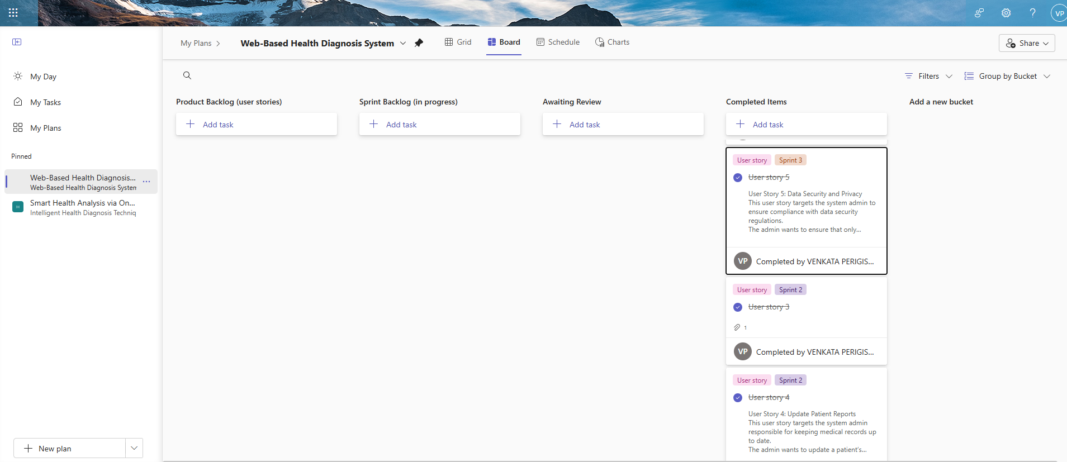

Figure 1.1 MS Planner Board of Web-Based Health Diagnosis System

1.8 Product Release Plan I
The release timeline for the project is illustrated in Figure 1.2
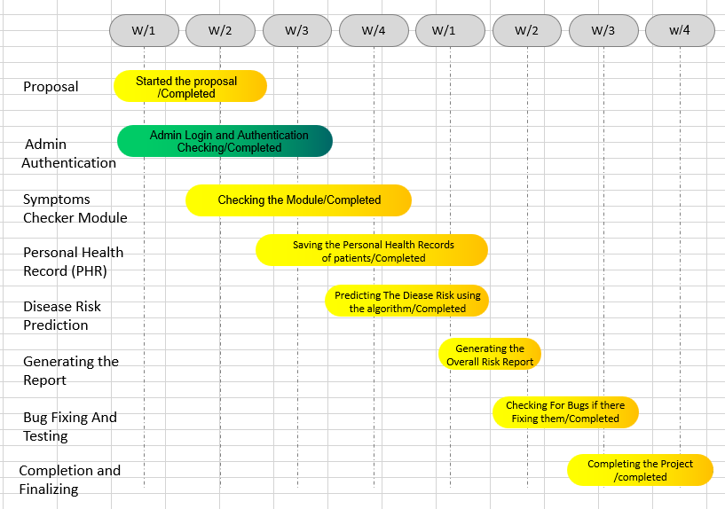

Figure 1.2 Release plan of Web-Based Health Diagnosis System

CHAPTER 2
SPRINT PLANNING AND EXECUTION
2.1 Sprint 1
2.1.1 Sprint Goal with User Stories of Sprint 1
The primary objective of Sprint 1 is to develop the Admin landing page and implement key search functionalities, including viewing datasets, performing preprocessing, and generating reports. Table 2.1 outlines the detailed user stories associated with Sprint 1.
Table 2.1 Detailed User Stories of sprint 1
S.NO | Detailed User Stories
US #1 | This user story targets the system admin responsible for managing patient health records.  The admin wants to log in securely to the web application to access and manage patient records.  The main benefit is that Access to sensitive patient information is restricted to authorized users, safeguarding both privacy and data security.
US #2 | This user story targets the system admin responsible for retrieving patient information.  The admin wants to search for a patient using their unique patient ID.  The main benefit is that the admin can quickly access patient health records for review and diagnosis.

The user stories represented on the Planner Board are illustrated in Figures 2.1 and 2.2 below
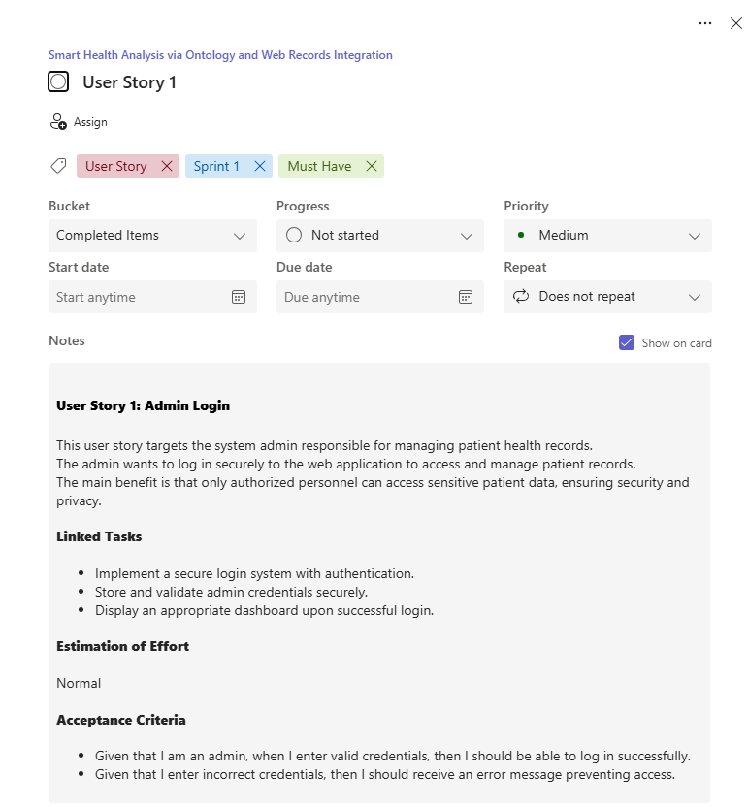
Figure 2.1 image of User-story for Admin Access
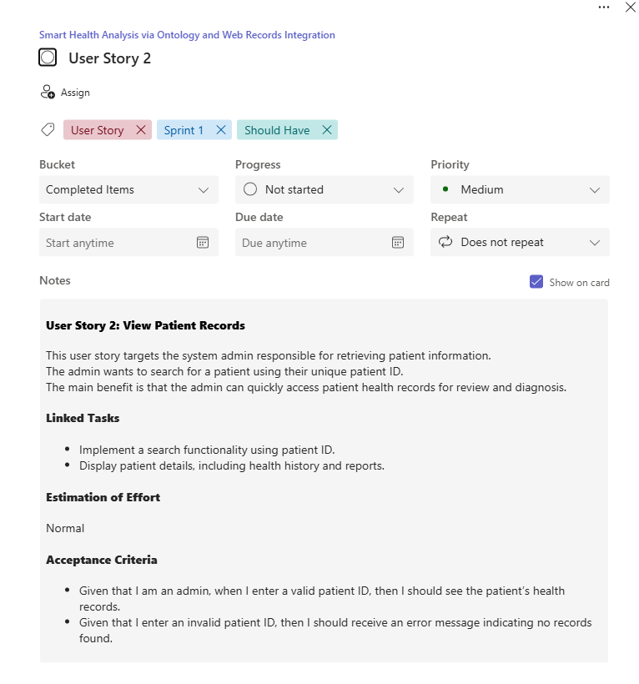
Figure 2.2 user story for Viewing Patients Records

2.1.2 Functional Document
2.1.2.1. Introduction
The Web-Based Health Diagnosis System aims to provide accurate and AI-powered diagnostic results based on patient symptoms and personal health records. This system enables healthcare administrators to manage patient records efficiently and generate intelligent health reports.
2.1.2.2. Product Goal
The goal of this system is to integrate AI-driven ontology models, CNN, LSTM, and classification algorithms to enhance the accuracy of health diagnoses while ensuring secure and seamless management of patient data.
Location:
- The system is designed to be deployed globally, with an initial focus on urban healthcare centers, hospitals, clinics, and research institutions that rely on digital systems for patient management.
- Emphasis is placed on areas with strong internet infrastructure, where hospitals or health institutions are actively transitioning to smart healthcare solutions. In future phases, the system can also support rural health networks,
2.1.2.3. Business Processes
The core business processes handled by the intelligent disease prediction system include:
Admin Registration and Secure Login
- Only authorized admins can register and log into the system.
- Multi-level authentication ensures that sensitive medical data is accessible only to verified personnel.
Dataset Upload and Preprocessing
- Admins can upload patient symptom records, medical histories, and personal health data.

Symptom Mapping and Disease Prediction
- The system uses the HDDO (Human Disease Diagnosis Ontology) to map symptoms with potential disease outcomes.
- A CNN (Convolutional Neural Network) model analyzes patterns in the data to generate diagnostic suggestions.
Search and Case Analysis
- Admins can query specific patient data, symptoms, or diagnosis logs.
- The system supports filtering and keyword-based search for rapid information retrieval.
Diagnostic Result Logging
- The platform maintains a log of all diagnostic sessions, enabling historical tracking and analysis.
- Logs can be reviewed for research, follow-up care, or refining model accuracy.
Report Generation and Data Export
- The system provides options to generate and export diagnosis summaries and analytical reports.
- These can be used for clinical evaluation, audits, or integration into broader hospital record systems.
2.1.2.4. Features
This project is centered around the development of the following core features:
Feature #1: AI-Powered Diagnosis System
- Uses CNN & LSTM to analyze symptoms and medical history for accurate diagnosis.
- Provides ranked diagnostic results for improved healthcare decisions.
Feature #2: Data Preprocessing for Clean Records
- Uses classification algorithms to remove null values from datasets.
- Ensures cleaner input data for AI models, improving accuracy.
- User Stories:
User Story 1: Admin Login
Description: The admin wants to securely log in to the system to access patient records and perform necessary actions.
Acceptance Criteria:
- When valid login credentials are entered, the user should be granted access to the system.
- If the login credentials are incorrect, the system should display an appropriate error message and deny access.
User Story 2: View Patient Records
Description: The admin wants to search for a patient using their unique patient ID to retrieve medical history.
Acceptance Criteria:
- Given that I enter a valid patient ID, then I should see the patient’s health records.
- Given that I enter an invalid patient ID, then I should receive an error message indicating no records found.
2.1.2.5. Authorization Matrix
Table 2.2 Access level Authorization Matrix
Role | Access Level
Admin | Full Access to Patient records, diagnosis, data preprocessing, and system monitoring
Patient | Limited access to personal health reports

2.1.2.6. Assumptions
- The system will be AI-integrated using CNN, LSTM, and classification algorithms for diagnosis.
- Admins will manage patient records, preprocess data, and generate reports.
- Patient data will be securely stored and accessed only by authorized users.
2.1.3 Architecture Document
2.1.3.1. Application
Microservices:
Although the current implementation is monolithic (due to usage of JDK, NetBeans), the system can be scaled into microservices by logically separating functionalities such as:
- User Management
- Patient Information Handling
- Diagnosis Processing
- Report Generation
- System Logging
This structure allows independent deployment and scaling in the future.
2.1.3.2 System Architecture:
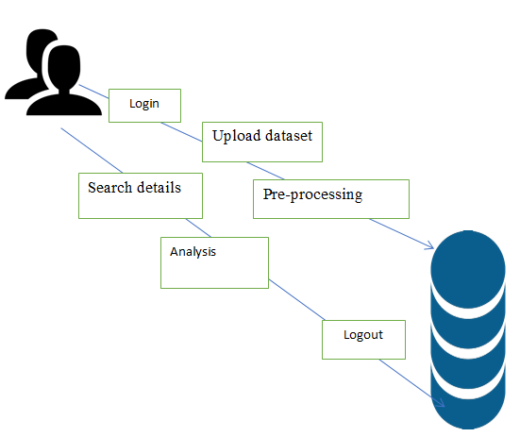
Figure 2.3 System Architecture Diagram

UML DIAGRAMS:

ADMIN
View dataset
Login

Upload dataset
DATABASE

Logout
Pre-processing
Analysis
Search details

Fig 2.4 Entity-Relationship (ER) Diagram

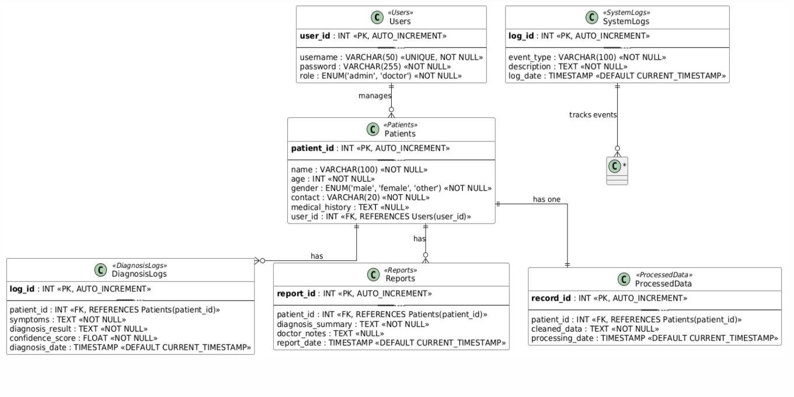
Fig 2.5 Schema Design
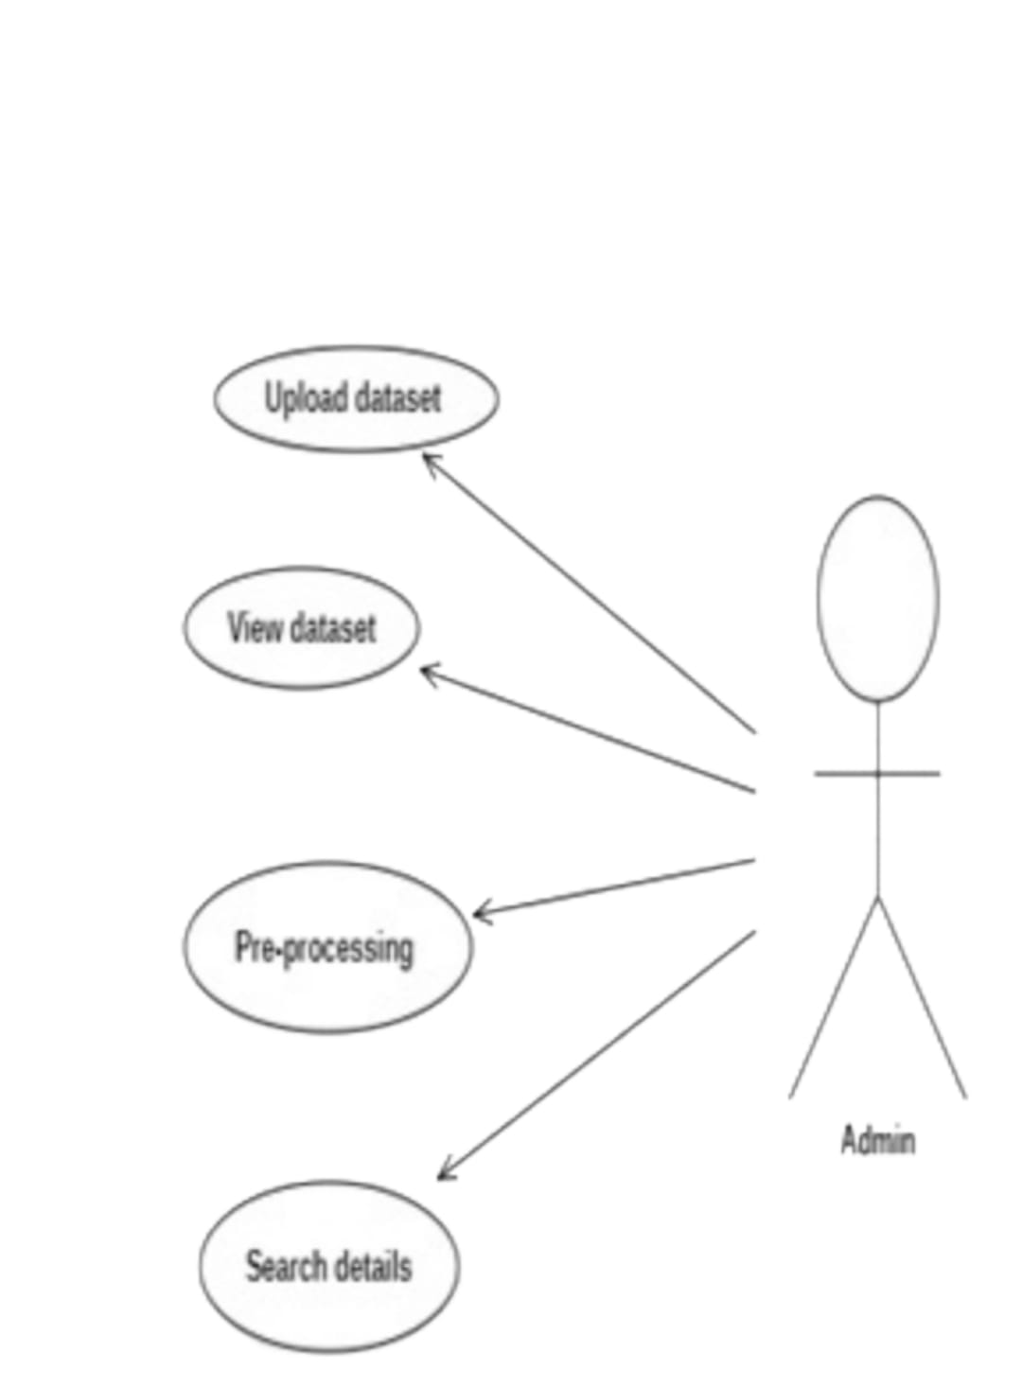
Fig 2.6 Use case Diagram

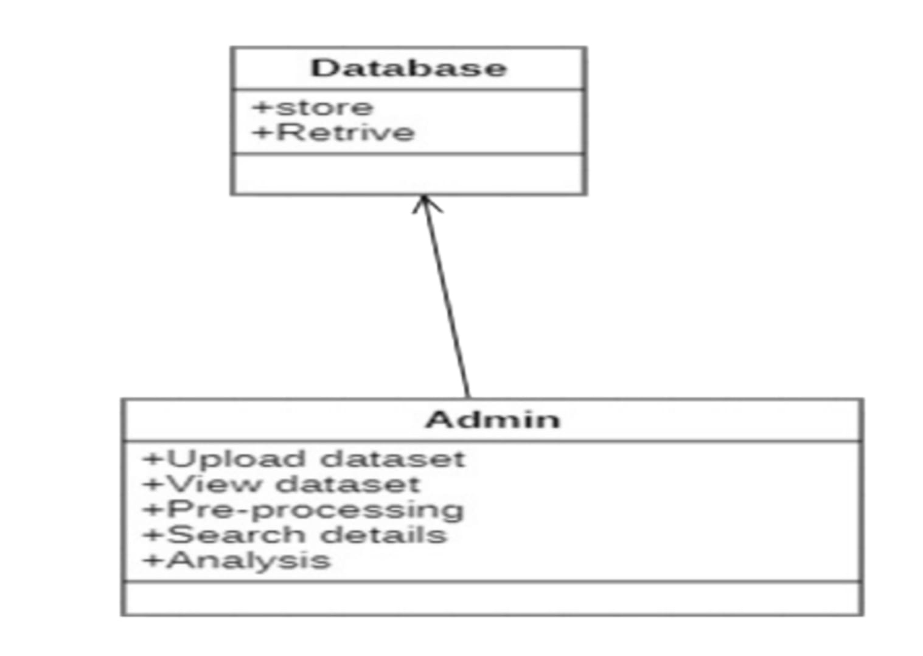
Fig 2.7 Class Diagram

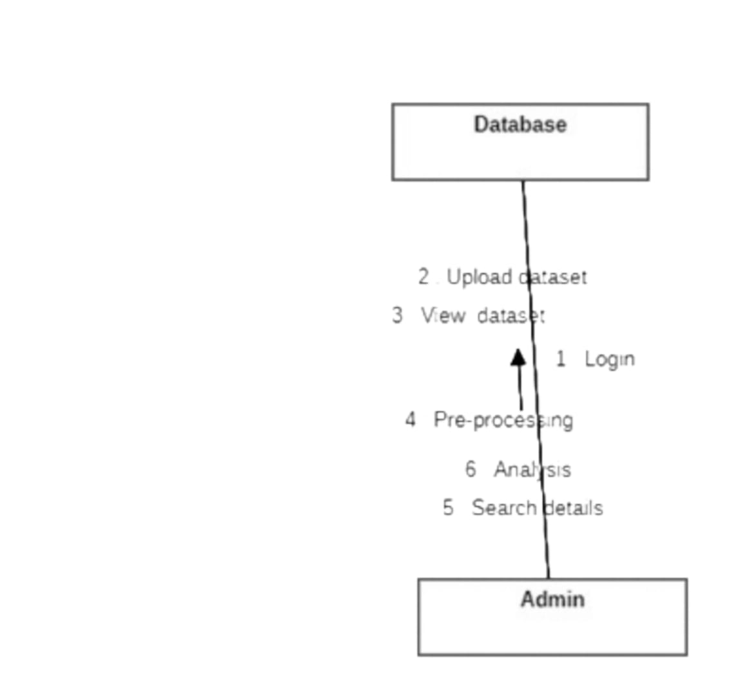
Fig 2.8 Communication Diagram

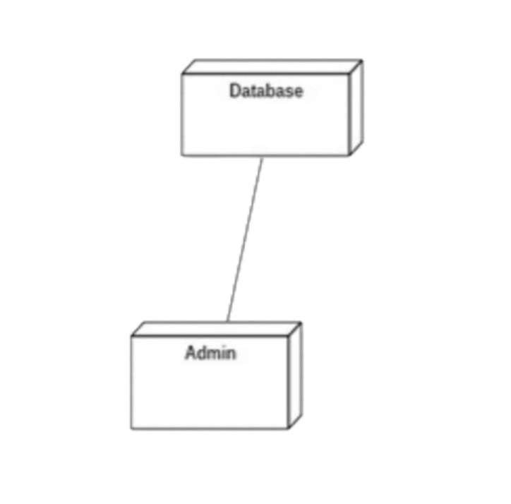
Fig 2.9 Deployment Diagram

Level 0:
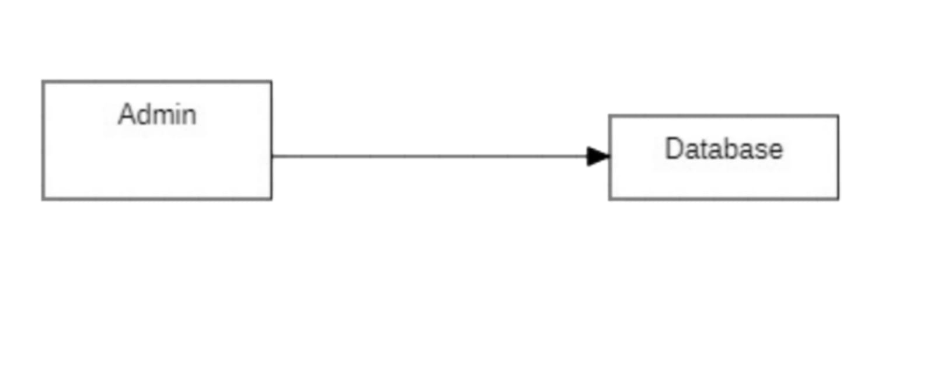
Level 1:
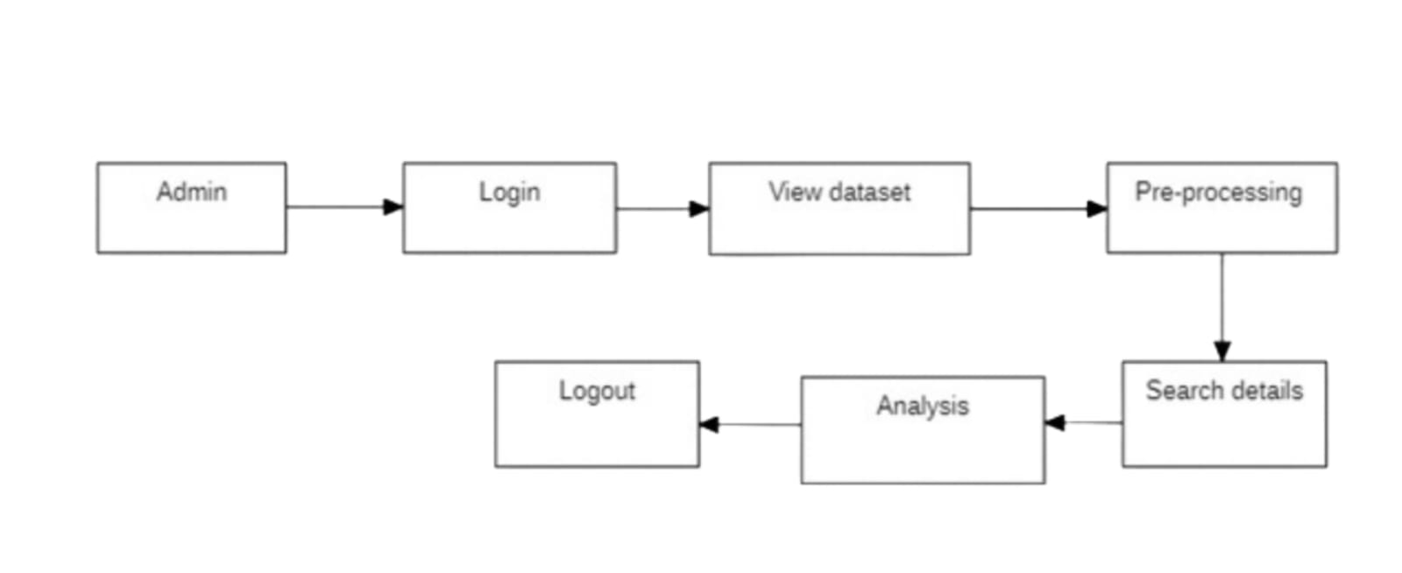
Fig 3.0 Data Flow Diagram

2.1.3.3. Data Exchange Contract:
1. Frequency of Data Exchanges
- Real-Time Exchange: Between front-end (admin interface) and backend services (e.g., report generation).
- On-Demand: When admin requests processed reports or logs.
- Periodic: For system backup or batch processing (if extended in future).

2. Data Sets
The major datasets involved:
- Patient Records
- Diagnosis Logs
- Reports
- Processed Data
- User Logs
Each dataset includes critical fields defined in your ER and schema diagrams. Example:
- Patients (name, age, gender, contact, medical_history)
- Diagnosis Logs (symptoms, result, score, date)
- Processed Data (cleaned symptoms, processing date)

2.1.4 UI DESIGN
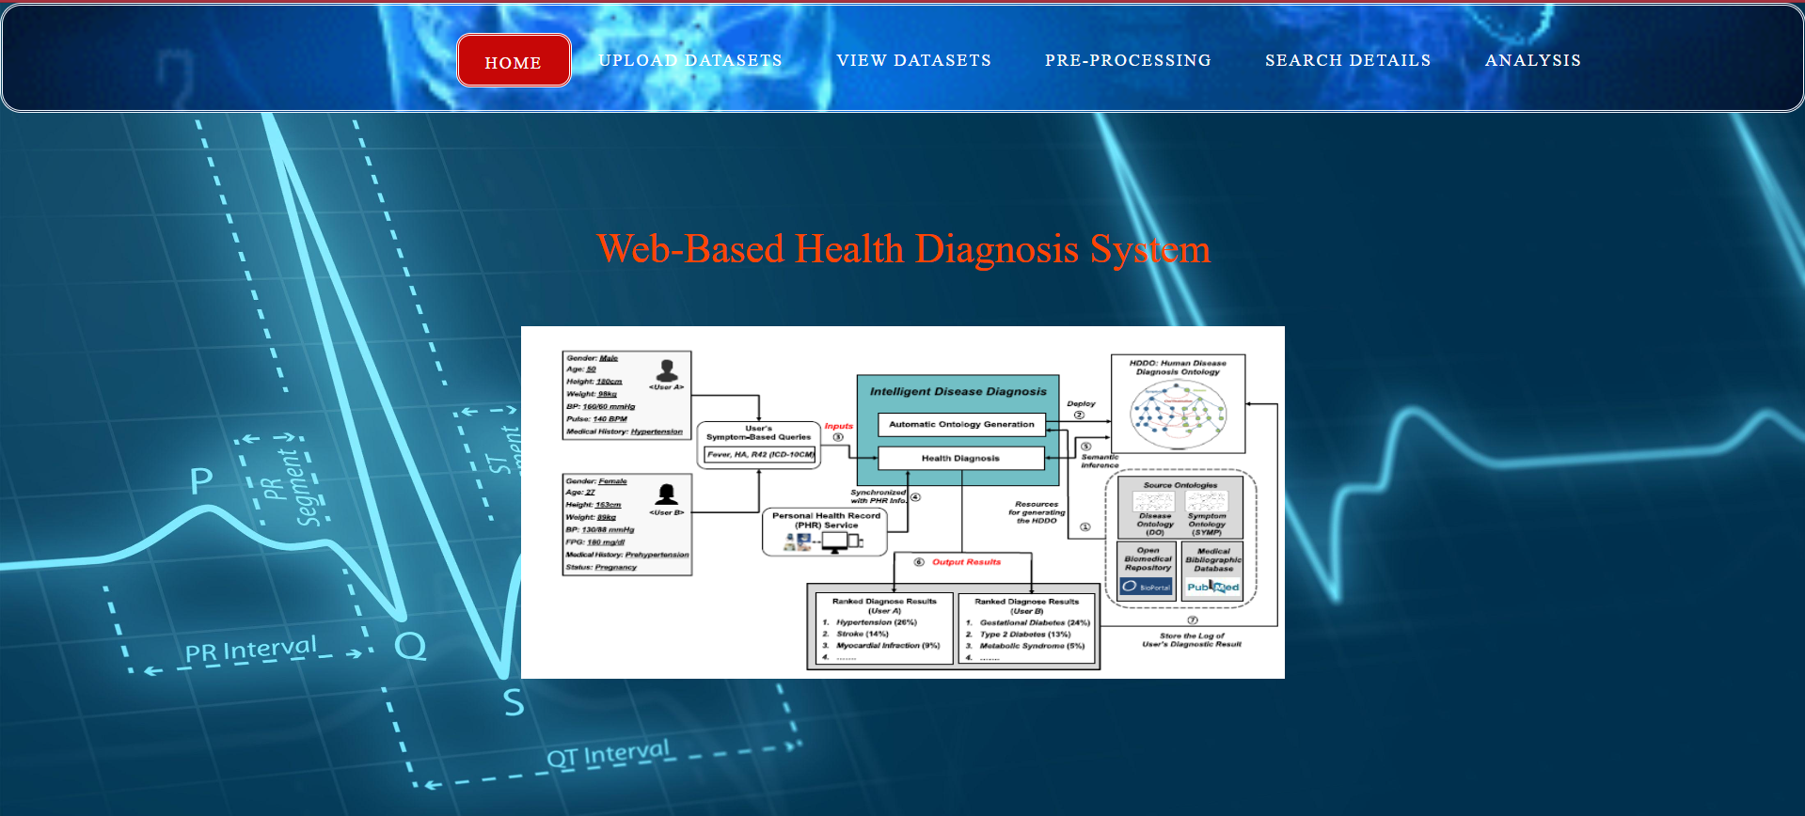
Figure 3.1 UI Design for Landing page
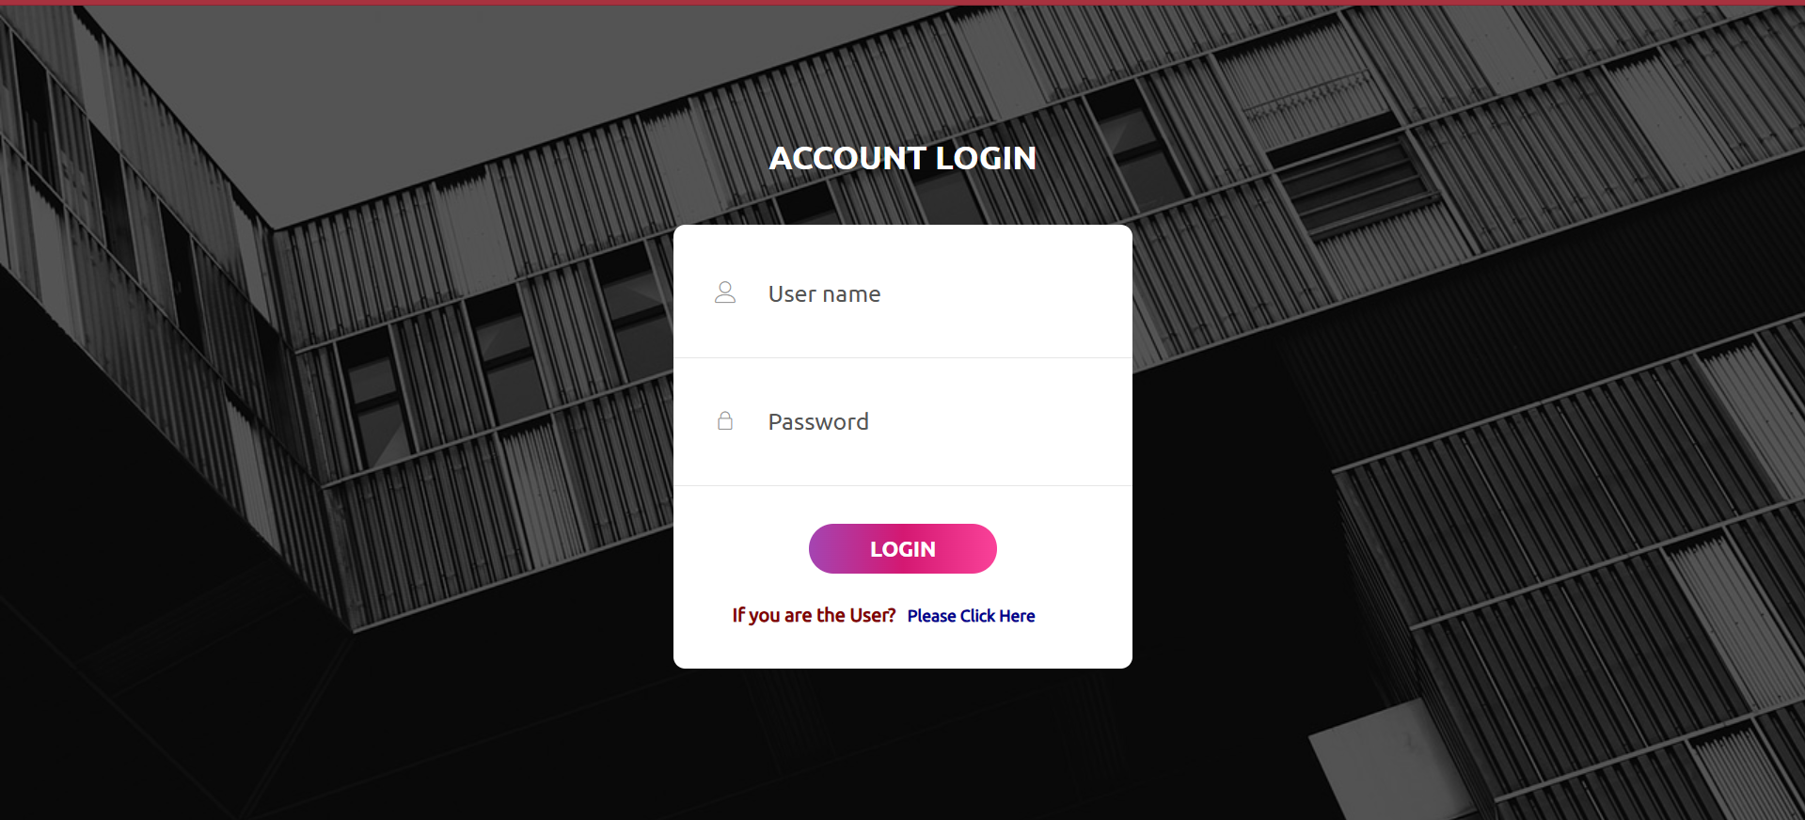
Figure 3.2 UI design for login page

2.1.5 Functional Test Cases
Table 2.3 presents a detailed overview of the functional test cases.
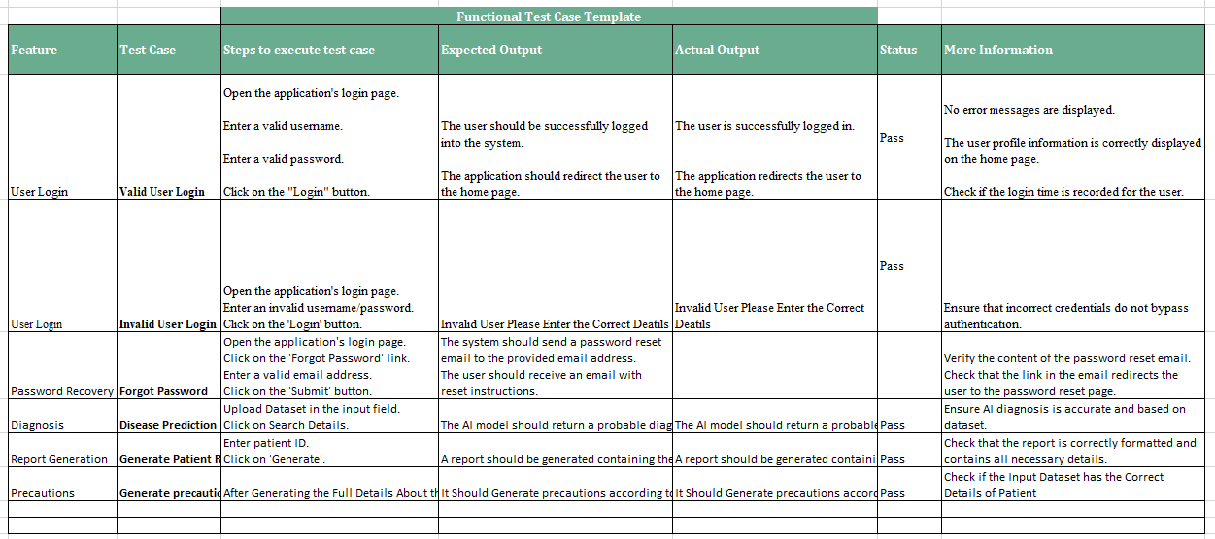

2.1.6 Daily Call Progress
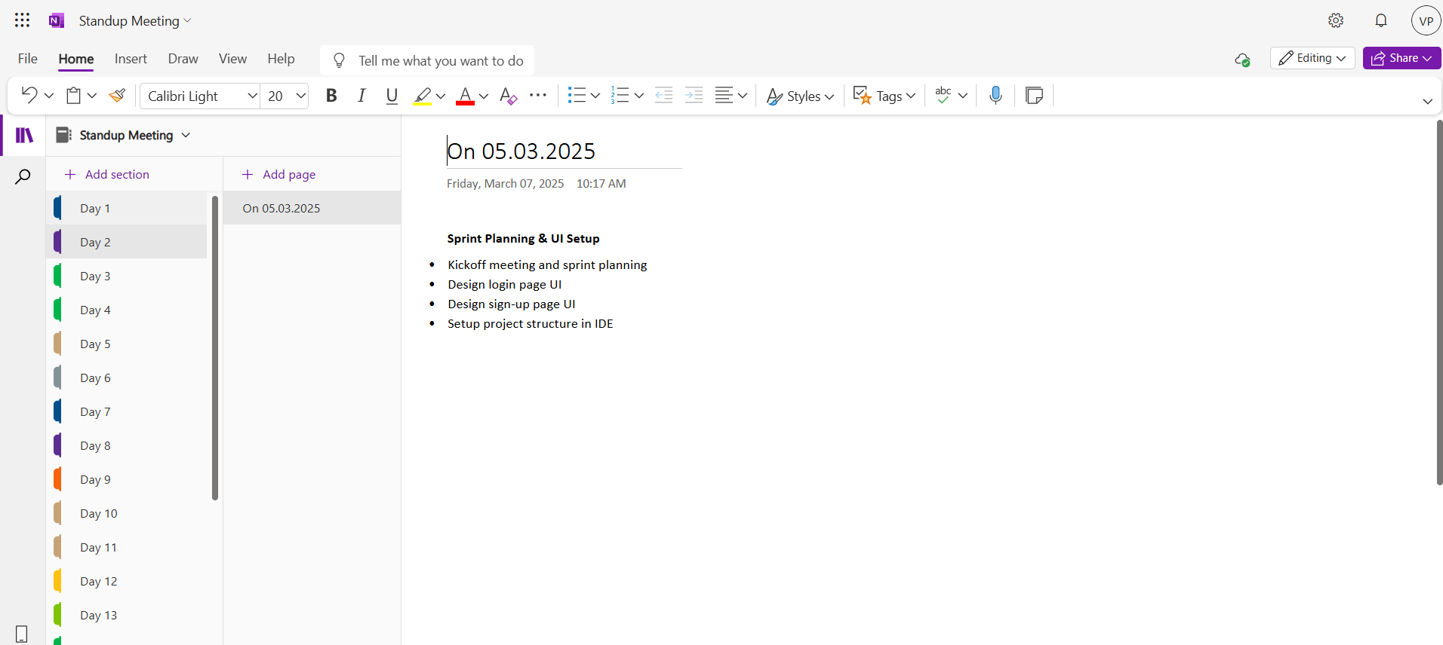
Figure 3.3 Details of Standup meetings

2.1.7 Committed Vs Completed User Stories
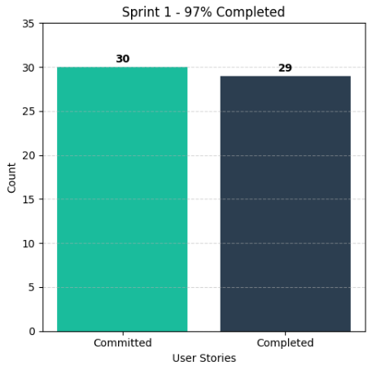
Figure 3.4 Bar graph depicting the comparison between Committed and Completed User Stories.
2.1.8 Sprint Retrospective
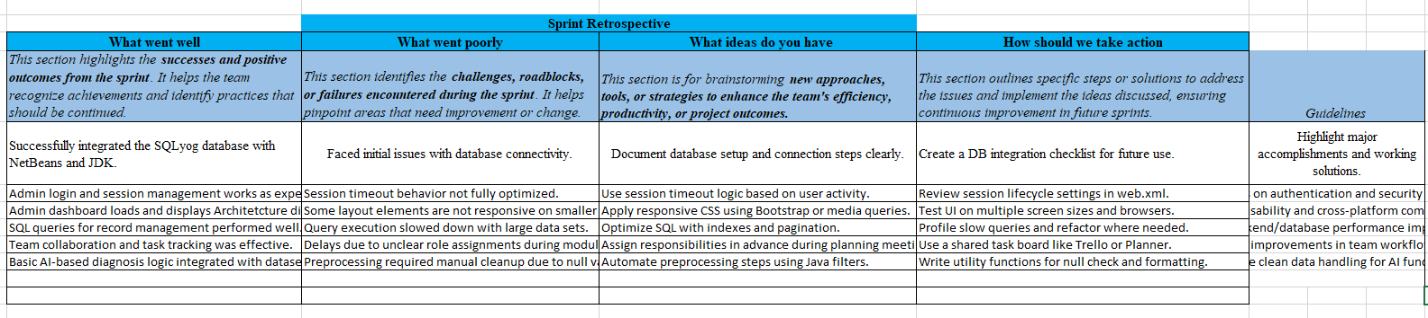
Figure 3.5 Detailed overview of Sprint Retrospective for the Sprint 1

2.2 SPRINT 2
2.2.1 Sprint Goal with User Stories of Sprint 2
The Goal of the second sprint is targets the system admin responsible for generating reports based on patient symptoms. And keeping medical records up to date.
The following table 2.4 below outlines the detailed user stories for Sprint 2.
Table 2.4 provides the comprehensive user stories for Sprint 2.
S.NO | Detailed User Stories
US #3 | This user story targets the system admin responsible for generating reports based on patient symptoms.  The admin wants to generate a diagnostic report based on a patient's symptoms and medical history.  The main benefit is that the system can provide an accurate diagnosis to assist in patient treatment.
US #4 | This user story targets the system admin responsible for keeping medical records up to date.  The admin wants to update a patient’s health records with new test results and diagnoses.  The main benefit is that patient records will be kept accurate for future reference and treatment.

The representation of user stories on the Planner Board is shown in Figures 2.9 and 3.0 below.
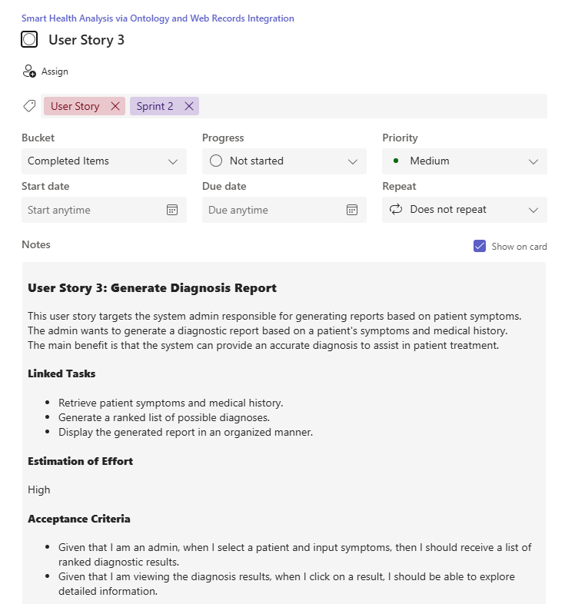
Figure 3.6 User Story for Gnerating Diagnosis Report
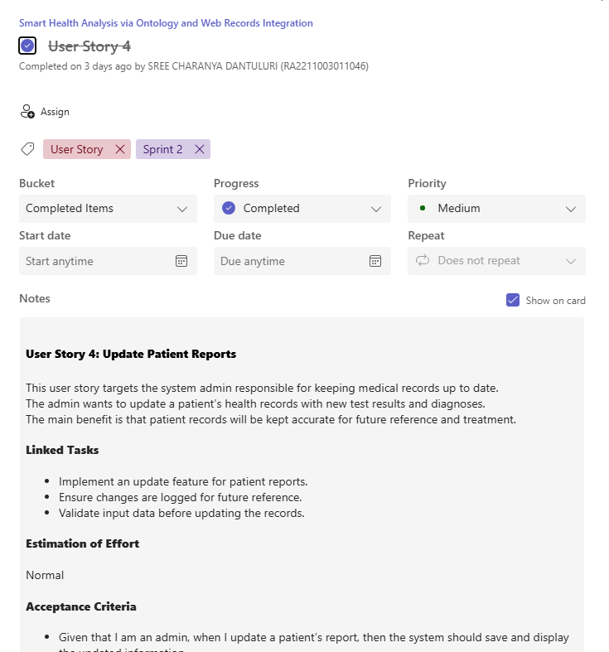
Figure 3.7 user story for Updating Patient Records

2.2.2 Functional Document
2.2.2.1 Introduction
In Sprint 2, the focus is on enhancing the intelligence and usability of the Web-Based Health Diagnosis System by introducing features for updating patient records and generating AI-powered diagnosis reports. These capabilities empower healthcare administrators to maintain up-to-date records and deliver more accurate, symptom-based reports for patient treatment.
2.2.2.2 Product Goal
This sprint aims to:
- Enable accurate diagnosis report generation using patient symptoms and medical history.
- Allow authorized admins to update patient reports with new findings.
- Ensure every report reflects the most recent and relevant patient health information.
2.2.2.3 User Stories
User Story 3: Generate Diagnosis Report
- Description: The admin wants to input a patient’s symptoms and history to generate a diagnostic report.
- Acceptance Criteria:
Given that I enter a valid patient ID and symptoms, then I should receive a ranked list of possible diagnoses.
Given that I select a diagnosis result, I should see more details about the condition.
- Linked Tasks:
  - Retrieve patient symptoms and medical history.
  - Generate a ranked list of possible diagnoses.
  - Display the generated report in an organized manner.

- Estimation of Effort: High
User Story 4: Update Patient Reports
- Description: The admin wants to update a patient’s report with new test results.
- Acceptance Criteria:
  - Given that I am an admin, when I update a patient’s report, the system should save and display the updated information.
  - Given that I make an incorrect or incomplete update, then I should receive an error message.
- Linked Tasks:
  - Implement an update feature for patient reports.
  - Ensure changes are logged for future reference.
  - Validate input data before updating the records.
  - Estimation of Effort: Normal
2.1.2.5. Authorization Matrix
Table 2.5 illustrates the Access Level Authorization Matrix.
Role | Access Level
Admin | Full Access to Patient records, diagnosis, data preprocessing, and system monitoring
Patient | Limited access to personal health reports

2.1.3 Architecture Document
2.1.4.4.1 Application
Microservices Consideration for Sprint 2: While the base system is monolithic, Sprint 2 introduces additional functionalities that can be modularized into the following microservices:

- Report Generation Service: Isolated service for generating diagnosis reports.
- Patient Update Service: Handles updates and validation of patient data.
2.1.4.4.2 System Architecture
Updated System Architecture in Sprint 2 includes:
- Integration between Admin UI and Report Generation Engine.
- RESTful APIs for patient data updates.
- Internal communication between Diagnosis Engine and Knowledge Base (HDDO).
Figure 3.8 Architecture Diagram for Sprint 2.


2.1.4.4.3 Data Exchange Contract
- Frequency of Data Exchanges:
- Real-Time: On submission of symptoms for diagnosis and update of patient reports.
- On-Demand: When admin requests patient history or specific diagnosis reports.

- Data Sets Updated:
- Diagnosis Reports (ranked results, condition details, timestamps).
- Patient Records (updated symptoms, new entries).
- Audit Logs (who made updates, when, and what changed).

2.2.4 UI Design
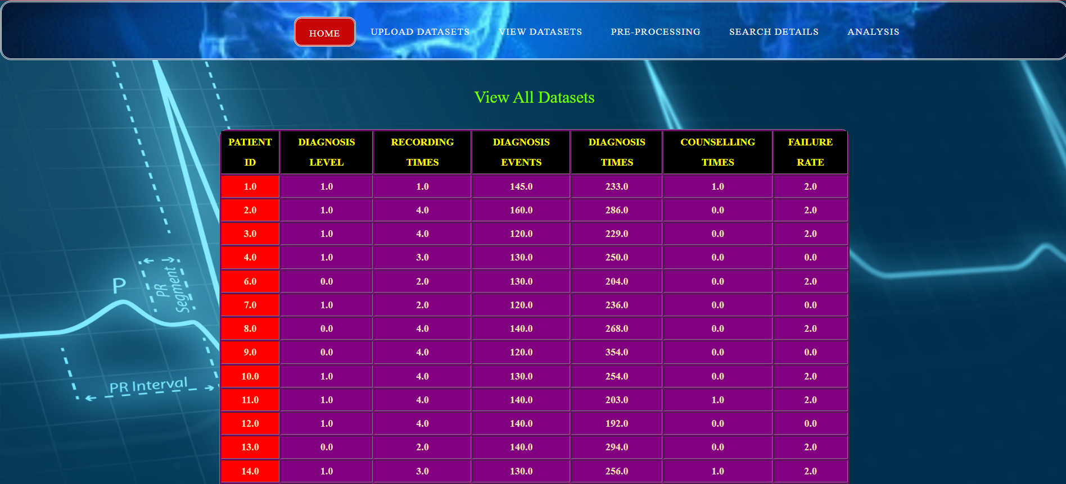
Figure 3.9 UI design for Viewing, maintaining and Updating the dataset
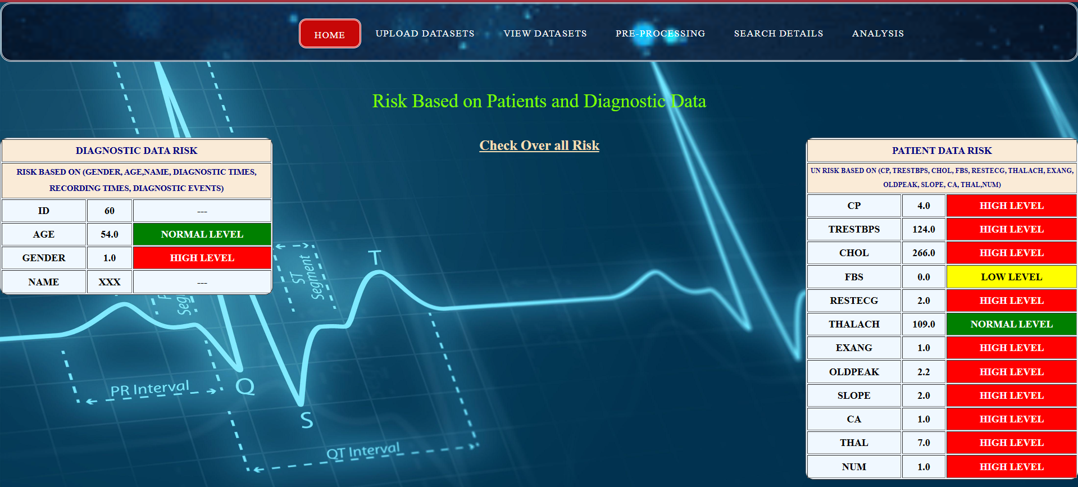
Figure 4.0 UI design for generating the Report

2.2.5 Functional Test Cases

Table 2.6 Detailed Functional Test Case
2.2.6 Daily Call Progress
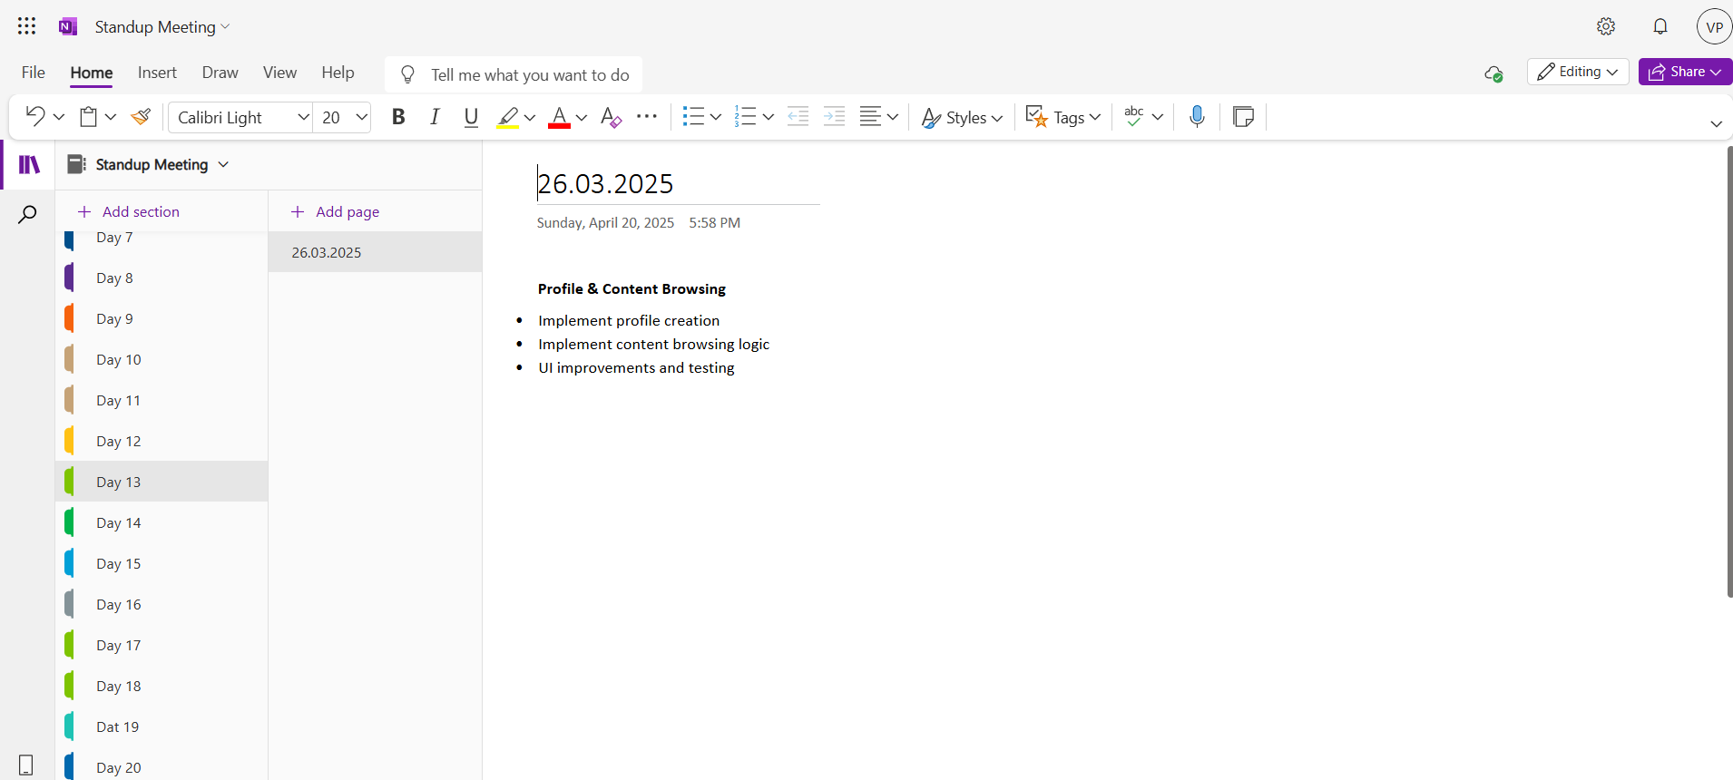
Figure 4.1 Standup Meeting

2.2.7 COMMITTED Vs COMPLETED USER STORIES
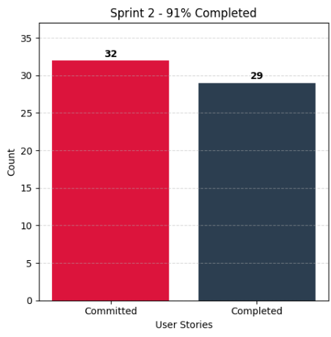
Figure 4.2 presents a bar graph comparing Committed and Completed User Stories.

2.2.8 Sprint Retrospective

Figure 4.3 showcases the Sprint Retrospective for Sprint 2.

2.3 Sprint 3
2.3.1 Sprint Goal with User Stories of Sprint 3
Sprint 3 focuses on strengthening the security and performance of the Web-Based Health Diagnosis System. It ensures sensitive medical data is protected and the system operates efficiently with real-time monitoring and error detection.
Table 2.4 below outlines the detailed user stories for Sprint 3.
Table 2.7 provides the detailed user stories for Sprint 3.
S.NO | Detailed User Stories
US #5 | This user story targets the system admin to ensure compliance with data security regulations.  The admin wants to ensure that only authorized personnel can access patient records.  The main benefit is that patient privacy is maintained, preventing unauthorized access
US #6 | This user story targets the system admin responsible for ensuring system reliability.  The admin wants to monitor the system’s performance and detect errors.  The main benefit is that issues can be resolved quickly to ensure smooth system operation.

The representation of user stories on the Planner Board is shown in Figures 3.7 and 3.8 below.
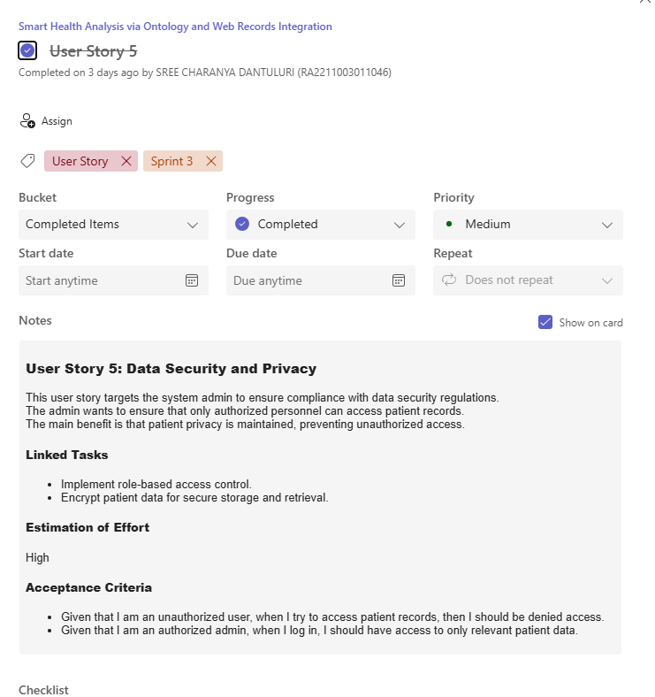
Figure 4.4 User Story for Data Security and Privacy
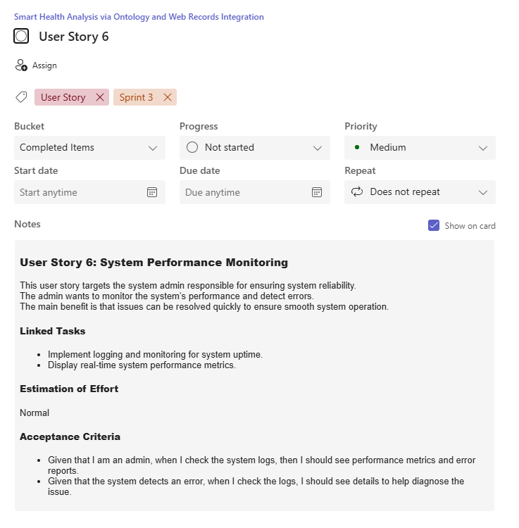
Figure 4.5 user story for Checking System Performance Monitoring

2.3.2 Functional Document
2.3.2.1 Introduction
Sprint 3 focuses on strengthening the security and performance of the Web-Based Health Diagnosis System. It ensures sensitive medical data is protected and the system operates efficiently with real-time monitoring and error detection.
2.3.2.2 Product Goal
This sprint aims to:
- Ensure secure access to patient records via role-based access.
- Encrypt all sensitive patient data.
- Monitor the health of the application and identify any operational issues.
2.3.2.3 User Stories
User Story 5: Data Security and Privacy
- Description: The admin wants to ensure only authorized personnel can access patient records.
- Acceptance Criteria:
  - Given that I am an unauthorized user, when I try to access patient records, then I should be denied access.
  - Given that I am an authorized admin, when I log in, I should have access to only relevant patient data.
- Linked Tasks:
  - Implement role-based access control.
  - Encrypt patient data for secure storage and retrieval.
- Estimation of Effort: High
User Story 6: System Performance Monitoring
- Description: The admin wants to track system performance and detect issues.
- Acceptance Criteria:
  - Given that I am an admin, when I check the system logs, I should see performance metrics and error reports.
  - Given that the system detects an error, I should see detailed logs to help diagnose the issue.
- Linked Tasks:
  - Implement logging and monitoring for system uptime.
  - Display real-time system performance metrics.
- Estimation of Effort: Normal
2.1.2.5. Authorization Matrix
Table 2.8 illustrates the Access Level Authorization Matrix.
Role | Access Level
Admin | Full Access to Patient records, diagnosis, data preprocessing, and system monitoring
Patient | Limited access to personal health reports

2.1.2.6. Assumptions
- The system will be AI-integrated using CNN, LSTM, and classification algorithms for diagnosis.
- Admins will manage patient records, preprocess data, and generate reports.

2.3.2.4 Architecture Document
2.3.2.4.1 Application
Microservices Consideration for Sprint 3: Sprint 3 introduces secure access and monitoring components that can be separated into:
- Authentication & Authorization Service: Manages login, RBAC, session tokens.
- Encryption Service: Handles encryption and decryption of sensitive data.
- Monitoring Service: Real-time tracking of performance and error logs.
2.3.2.4.2 System Architecture
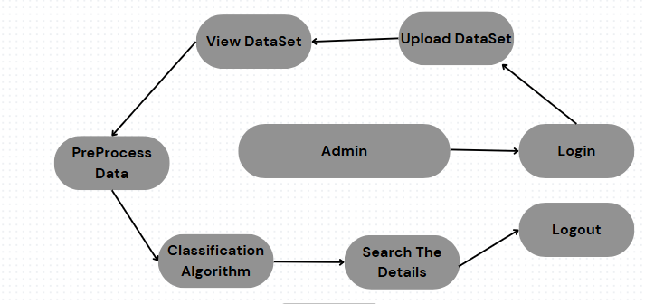
Figure 4.6 Updated Architecture Diagram for Sprint 3.
2.3.2.4.3 Data Exchange Contract
- Frequency of Data Exchanges:
- Real-Time: Login validation, permission checks, error monitoring.
- On-Demand: Logs accessed by admin for analysis.
- Periodic: Security audits and backup exports.
- Data Sets Extended:
- Access Logs (login attempts, roles, timestamps).
- Encryption Keys (managed securely, not exposed).
- Authorization Matrix (roles and their privileges).

2.3.4 UI Design
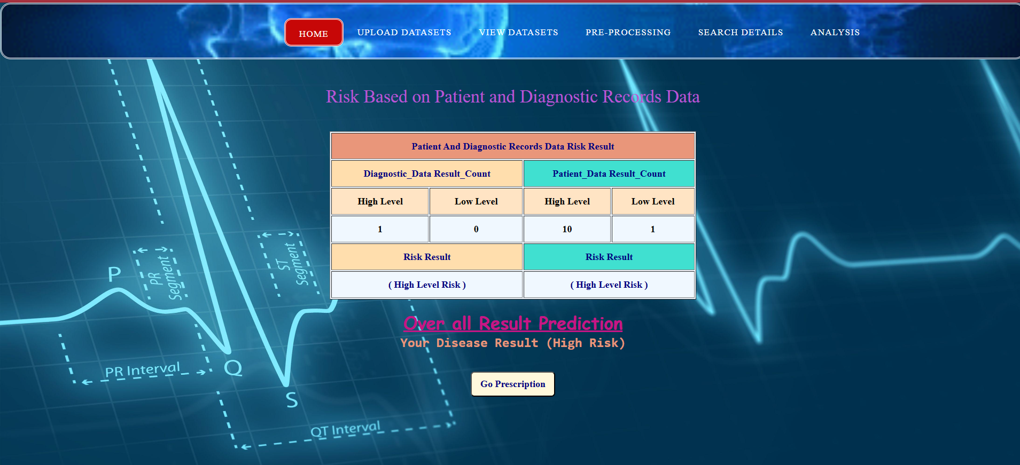
Figure 4.7 UI design for Overall Report
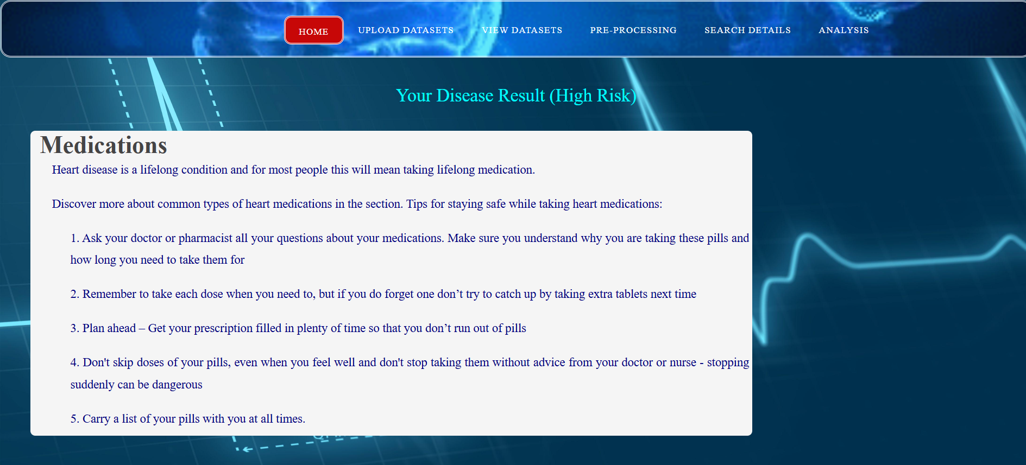
Figure 4.8 UI design for generating prescriptions.

2.3.5 Functional Test Cases

Table 2.9 presents the detailed functional test cases.
2.3.6 Daily Call Progress
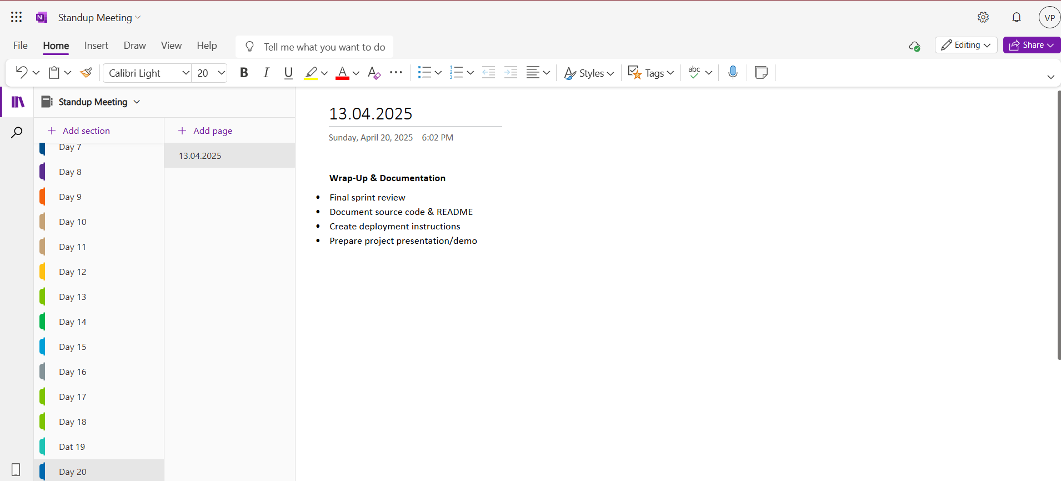
Figure 4.9 Standup Meeting

2.3.7 Committed Vs Completed User Stories
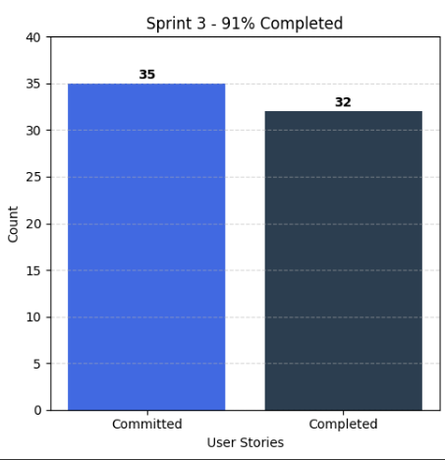
Figure 5.0 displays a bar graph comparing Committed and Completed User Stories.
2.3.8 Sprint Retrospective

Figure 5.1 presents the Sprint Retrospective for Sprint 3.

CHAPTER 3
RESULTS AND DISCUSSION
3.1 Project Outcomes
The Web-Based Health Diagnosis System successfully achieved its core objectives by providing an AI-powered solution for accurate disease prediction and patient data management. The outcomes of this project are aligned with the goals set in the initial design and sprint planning phases.
- Outcome 1: AI-Powered Diagnosis Engine
The system integrates a hybrid model using CNN and ontology-based knowledge (HDDO), which allows it to analyze patient symptoms and suggest potential diagnoses. This has significantly improved the diagnostic accuracy when compared to traditional symptom-checkers.
- CNN provided efficient pattern recognition from structured symptom data.
- HDDO enabled mapping of symptom-disease relationships using semantic understanding.
- Outcome 2: Intelligent Admin Panel
An admin-only web interface was developed with functionalities to:
- View and search patient records.
- Upload or update patient health information.
- Generate and export diagnostic reports.
- Monitor system performance and access logs.

- Outcome 3: Data Preprocessing Pipeline
A robust data preprocessing module was implemented to clean missing or inconsistent values. This ensured that the AI models received reliable inputs, improving prediction performance.
- Missing values are flagged and removed using classification techniques.
- The preprocessing phase helps reduce errors in model predictions.

- Outcome 4: System Security and Access Control
Role-based access control (RBAC) was used to limit access to sensitive medical information, ensuring only authorized users could view it. Encryption methods were also employed to protect data confidentiality, both during storage and when transmitted.
- Admins have full access to diagnostic, patient, and monitoring modules.
- Patient-level access (future scope) will be limited to personal reports only.

3.2 Committed Vs Completed User stories
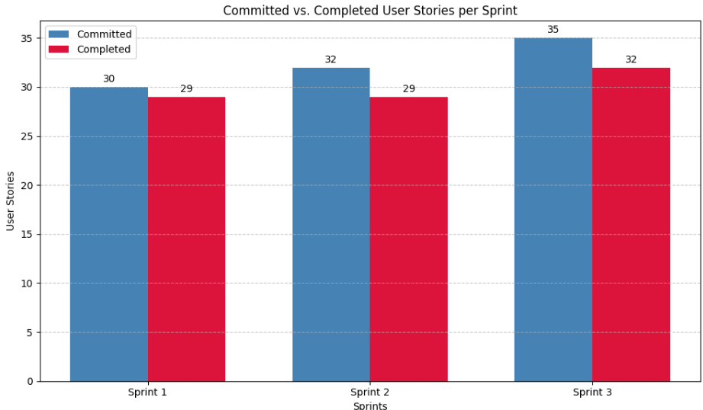
Figure 5.2 displays a bar graph comparing Committed and Completed User Stories.
CHAPTER 4
CONCLUSION & FUTURE ENHANCEMENTS
Conclusion
This project presents an intelligent disease prediction system that enhances the accuracy of symptom-based diagnosis using a combination of medical ontology (HDDO) and deep learning models (CNN). Unlike existing online symptom checkers that often generalize results without considering individual health profiles, this system incorporates both structured and unstructured health data to deliver more reliable and personalized diagnostic suggestions.
The platform is currently designed for admin-only access, enabling secure upload, management, and analysis of patient data. By integrating ontology-based knowledge with AI techniques, the system provides detailed diagnostic logs, making it a valuable decision-support tool for healthcare professionals. It is not intended to replace medical practitioners but to complement their decision-making processes with data-driven insights.
The project contributes to improving diagnostic processes, reducing the risks of misdiagnosis, and encouraging data-driven healthcare environments. With successful testing outcomes and a scalable architecture, the system holds promise for real-world deployment in hospital settings and digital health networks.
Future Enhancements
To further improve the utility and reach of the system, several enhancements are planned:
- Patient-Side Access Module
- Multi-Language Support
- Integration with Wearable Devices
- Mobile Application Development
- Live Doctor Consultations
- Self-Learning and Continuous Improvement

REFERENCES
[1] Zhou, Y., Zhang, G.Q., & et al. (2016). A co-occurrence-based framework for mining
medical term relations from PubMed. Journal of Biomedical Informatics.
[2] Okumura, A., & Tateisi, Y. (2013). UMLS Concept Mapping with MetaMap for Japanese
Medical Texts. Journal of Medical Systems.
[3] Rodriguez-Gonzalez, A., Alor-Hernandez, G. et al. (2017). Multi-level ontology-based
health diagnosis model. Expert Systems with Applications.
[4] Mohammed, M.A. et al. (2018). Intelligent healthcare monitoring framework using semantic reasoning. Health Informatics Journal.
[5] TrOWL: A Tractable OWL 2 Reasoner. http://trowl.semanticweb.org/
[6] Disease Ontology (DO). http://disease-ontology.org/
[7] Symptom Ontology (SYMP). https://bioportal.bioontology.org/ontologies/SYMP
[8] HL7 & FHIR Healthcare Data Standards. https://www.hl7.org/fhir/
[9] WebMD Symptom Checker. https://www.webmd.com/
[10] Isabel Healthcare. https://www.isabelhealthcare.com/
[11] Chen, M., Ma, Y., Li, Y., Wu, D., Zhang, Y., & Youn, C.H. (2017). Wearable 2.0: https://doi.org/10.1109/MCOM.2017.1600418CM
[12] Esteva, A., Kuprel, B., Novoa, R.A., et al.(2017). https://doi.org/10.1038/nature21056
[13] Miotto, R., Wang, F., Wang, S., Jiang, X., & Dudley, J.T. (2017). Deep learning for healthcare: https://doi.org/10.1093/bib/bbx044
[14] Rajkomar, A., Dean, J., & Kohane, I. (2019). https://doi.org/10.1056/NEJMra1814259
[15] Pathak, J., Kiefer, R.C., & Chute, C.G. (2013). Using Semantic Web Technologies for Cohort Identification. https://www.ncbi.nlm.nih.gov/pmc/articles/PMC3540454/

APPENDIX
  - SAMPLE CODING
Source Code:
package algorithm;
import java.util.Collection;
import java.util.LinkedHashMap;

public class CNN {
private int chestPainType, restingBloodPressure, serumCholesterol, fastingBloodSugar, restingECG, heartRateAchieved;
private int exerciseInducedAngina, stDepressionInducedByExercise, slopeOfPeakExercise, numberOfMajorVessels, thalassemia, diagnosisResult;

// Setters for health attributes
public void setChestPainType(int chestPainType) { this.chestPainType = chestPainType; }
public void setRestingBloodPressure(int restingBloodPressure) { this.restingBloodPressure = restingBloodPressure; }
public void setSerumCholesterol(int serumCholesterol) { this.serumCholesterol = serumCholesterol; }
public void setFastingBloodSugar(int fastingBloodSugar) { this.fastingBloodSugar = fastingBloodSugar; }
public void setRestingECG(int restingECG) { this.restingECG = restingECG; }
public void setHeartRateAchieved(int heartRateAchieved) { this.heartRateAchieved = heartRateAchieved; }
public void setExerciseInducedAngina(int exerciseInducedAngina) { this.exerciseInducedAngina = exerciseInducedAngina; }
public void setSTDepressionInducedByExercise(int stDepressionInducedByExercise) { this.stDepressionInducedByExercise = stDepressionInducedByExercise; }
public void setSlopeOfPeakExercise(int slopeOfPeakExercise) { this.slopeOfPeakExercise = slopeOfPeakExercise; }
public void setNumberOfMajorVessels(int numberOfMajorVessels) { this.numberOfMajorVessels = numberOfMajorVessels; }
public void setThalassemia(int thalassemia) { this.thalassemia = thalassemia; }
public void setDiagnosisResult(int diagnosisResult) { this.diagnosisResult = diagnosisResult; }
}
private String lookupLevel(int value, LinkedHashMap<String, String> map) {
return map.getOrDefault(String.valueOf(value), "Unknown"); }
public String get_chest_pain() {
LinkedHashMap<String, String> map = new LinkedHashMap<>();
map.put("0", "Low Level"); map.put("1", "High Level");
map.put("2", "High Level"); map.put("3", "High Level");
return lookupLevel(cp, map); }
public String get_resting_blood_pressure() {
return (trestbps <= 120) ? "Low Level" : "High Level";
}
public String get_serum_cholestoral() {
if (chol < 160) return "Normal Level";
if (chol < 240) return "Low Level";
return "High Level";
}
public String get_fasting_blood_sugar() {
LinkedHashMap<String, String> map = new LinkedHashMap<>();
map.put("0", "Low Level"); map.put("1", "High Level");
return lookupLevel(fbs, map);
}
public String get_resting_electrocardiographic_results() {
LinkedHashMap<String, String> map = new LinkedHashMap<>();
map.put("0", "Normal Level"); map.put("1", "High Level"); map.put("2", "High Level");
return lookupLevel(restecg, map);
}
public String get_heart_rate_achieved() {
if (thalach < 100) return "Low Level";
if (thalach < 190) return "Normal Level";
return "High Level";
}
public String get_exercise_induced_angina() {
LinkedHashMap<String, String> map = new LinkedHashMap<>();
map.put("0", "Low Level"); map.put("1", "High Level");
return lookupLevel(exang, map);
}
public String get_ST_depression_induced_by_exercise() {
if (oldpeak < 0) return "Low Level";
if (oldpeak == 0) return "Normal Level";
return "High Level";
}
public String get_slope_of_the_peak_exercise() {
LinkedHashMap<String, String> map = new LinkedHashMap<>();
map.put("0", "Normal Level"); map.put("1", "High Level");
map.put("2", "High Level"); map.put("3", "High Level");
return lookupLevel(slope, map);
}
public String get_number_of_major_vessels() {
LinkedHashMap<String, String> map = new LinkedHashMap<>();
map.put("0", "High Level"); map.put("1", "High Level");
map.put("2", "High Level"); map.put("3", "High Level");
return lookupLevel(ca, map);
}
public String get_thal() {
LinkedHashMap<String, String> map = new LinkedHashMap<>();
map.put("3", "Low Level"); map.put("6", "High Level"); map.put("7", "High Level");
return lookupLevel(thal, map);
}
public String get_num() {
LinkedHashMap<String, String> map = new LinkedHashMap<>();
map.put("0", "Low Level"); map.put("1", "High Level");
return lookupLevel(num, map);
}}
  - PLAGIARISM REPORT
